Project information
Project full title | Connecting Russian and European Measures for Large-scale Research Infrastructures – plus
Project acronym | CREMLINplus
Grant agreement no. | 871072
Instrument | Research and Innovation Action (RIA)
Duration | 01/02/2020 – 31/01/2024
Website | www.cremlinplus.eu

Milestone information
Milestone no. | MS26
Milestone title | Release of the software framework for SCT detector
Milestone responsible | BINP
Related Work-Package/Task | WP5 (MS5.1); task 5.3
Type (e.g. Report; other) | Conference contribution
Author(s) | A. Sukharev
Dissemination level
Document Version
Date | 31 Jul 2021
Download page

Document information
Version no. | Date | Author(s) | Comment
1 | 15 Jul 2021 | A. Sukharev

Table of Contents
- Introduction
- SCT detector software framework release
- Conference contributions

1. Introduction
The design and optimisation of a high energy physics experiment requires a complex software stack comprising a number of common tasks such as: detector geometry description, event simulation and simulation of detector responses, signal digitisation, event reconstruction and physics analysis. For an experiment in preparation, the software stack needs to be fully flexible and modular, such that the performance of different detector technology options and different detector geometries can be assessed. This stack is usually referred to as the software framework. The main elements of the software framework and data flows are shown in Fig. 1.
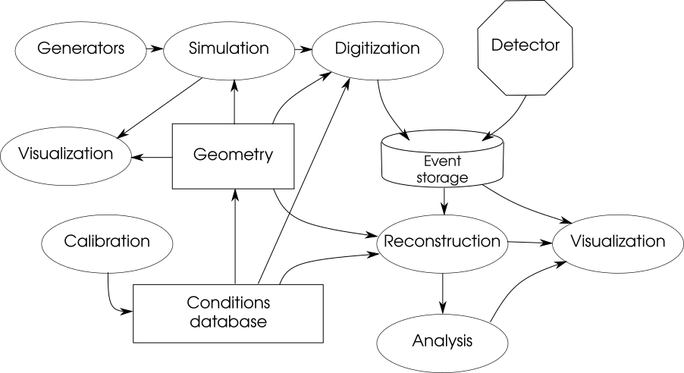
Fig. 1. Main detector software components and data flows.
The software framework is essential at the very early stages of the experiment design to allow the experimental crew to simulate and evaluate various options for the detector construction and to establish the physics potential and physics program of the experiment.

2. SCT detector software framework release
The SCT detector software framework is named Aurora, and it incorporates as much as possible of existing conventional high energy physics software. The Aurora release 1.0.0 has been published in March 2021. It features a minimal subset of components, as required at the present stage of the detector project:
- primary event generators,
- parameterized and full simulation,
- detector geometry description (with at least a basic description for all detector elements, and several options for some subsystems),
- sample digitization module,
- reconstruction modules (from basic to really advanced, depending on the sub-system),
- analysis and job configuration tools,
- test and service tools.
The bugfix release 1.0.1 has been published in June 2021.

3. Conference contributions
The Aurora 1.0.0 release was presented at
- The Asian Forum for Accelerators and Detectors (AFAD-2021) March 17, 2021.
- 25th International Conference on Computing in High-Energy and Nuclear Physics (vCHEP2021) May 19, 2021. This contribution will be published in European Physical Journal (EPJ) Web of Conferences.

